Data Flow Diagram Tutorial/Lab Exercise

A Data Flow Diagram (DFD) is also known as a Process Model. Process Modeling is an analysis technique used to capture the flow of inputs through a system (or group of processes) to their resulting output. The model is fairly simple in that there are only four types of symbols – process, dataflow, external entity, data store. An example can be found on page 146 in our textbook. The Gane and Sarson Symbol technique is employed there.

Process Modeling is used to visually represent what a system is doing. It is much easier to look at a picture and understand the essence than to read through verbiage describing the activities. System Analyst after talking with various users will create DFD diagrams and then show them to users to verify that their understanding is correct. The process models can be created to represent an existing system as well as a proposed system.

The following clarifies what each symbol in Process Modeling represents; the information is taken from out textbook on pages 147-149.
:
Process – An activity or a function that is performed for some specific reason; can be manual or computerized; ultimately each process should perform only one activity

Data Flow – single piece of data or logical collection of information like a bill

Data Store – collection of data that is permanently stored

External Entity – A person, organization, or system that is external to the system but interacts with it

Be aware of the basic rules for Process Modeling:
- A series of data flows always starts or ends at an external agent and starts or ends at a data store. Conversely, this means that a series of data flows can not start or end at a process.
- A process must have both data inflows and outflows.
- All data flows must be labeled with the precise data that is being exchanged.
- Process names should start with a verb and end with a noun.
- Data flows are named as descriptive nouns.
- A data store must have at least one data inflow.
- A data flow can not go between an external agent and a data store, but a process must be in between.
- A data flow can not go between to external agents, but a process must be in between.
- A data flow can not go between to data stores, but a process must be in between.
- External agents and data flows can be repeated on a process model in order to avoid lines crossing, but do not repeat processes.

A Context Model is done first when completing the process models for a system. It represents the system with a single process and then shows the external agents with which the system interacts. A context diagram is often named the name of the system and does not start with a verb as do other processes. Typically data stores are not part of a context model since these would be internal to the system. By creating the context model first the system analyst focuses on the outward communications and exchanges and later the inward communications and exchanges.

After the context model is created the process is exploded to the next level to show the major processes in the system. Depending upon the complexity of the system each of these processes can also be exploded into their own process model. This continues until the goal of each process accomplishing a single function is reached. Because of this approach the context model is referred to as Level 0 (Zero) DFD, the next as Level 1 DFD, etc.

To better understand this technique let’s look at an example case and create a Level 0 and maybe a Level 1 process models for it.

CASE:
The purpose of the green acres real estate system is to assist agents as they sell houses. Sellers contact the agency, and an agent is assigned to help the seller complete a listing reqeuest. Information about the house and lot taken from that request is stored in a file. Personal information about the sellers is copied by the agent into a sellers file.
When a buyer contacts the agency, he or she fills out a buyer request. Every two weeks, the agency sends prospective buyers area real estate listings and an address cross reference listing containing actual street addresses. Periodically, the agent will find a particular house that satisfies most or all of a specific buyer’s requirements, as indicated in the buyer’s requisrements statement distributed weekly to all agents. The agent will occasionally photocopy a picture of the house along with vital data and send the multiple listing statement (mls) to the potential buyer.
When the buyer selects a house, he or she fills out an offer that is forwarded through the real estate agency to the seller, who responds with either an offer acceptance or a counteroffer. After an offer is accepted, a purchase agreement is signed by all parties. After a purchase agreement is notarized, the agency sends an appraisal request to an appraiser, who appraises the value of the house and lot. The agency also notifies its finance company with a financing application.

First we will do the context diagram or Level 0 DFD. Start by identifying all the external agents and the data flows from them to the system. You will then need to open Microsoft’s Visio software and select new diagram type of data flow model diagram under the software category.

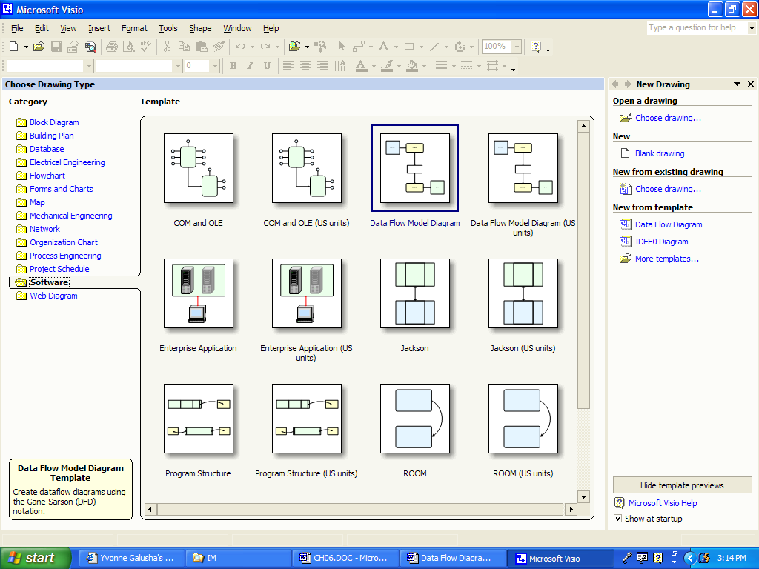
Select the external interfaces and process and place them on your page.

To determine the data flows it may help to create an Event Response List. For our case it would look something like this.

EVENT LIST

Event Description | Trigger (Inputs) | Responses (Outputs)
Seller enter into agreement to have agency sell house | Listing Request | Create Listing  Create Seller
Buyer initiates contact with agency about buying a home. | Buyer Request | Area Real Estate Listing  Address Cross Reference  Multiple Listing Statement  Buyer’s Requirement Statement
Buyer makes offer on house. | Offer | Offer Document
Seller accepts buyer’s offer. | Purchase Agreement | Notarized Purchase Agreement
Seller makes counteroffer to seller. | Counteroffer | Counteroffer document
Agency sends a request to a appraiser to have house appraised. | Appraisal Request | Appraisal of House report
Agency notifies financial company of opportunity to finance house. | Financing Application | Financing Program Offer

These events become the data flows on the context diagram. Next you are ready to add the data flows to your diagram.

Be sure and use the connector tool as I demonstrate in class to do your data flows instead of dragging that object onto the page. If you don’t do this, you will not carry those data flows over when you explode to the next level of diagram. Your top level should look something like this:

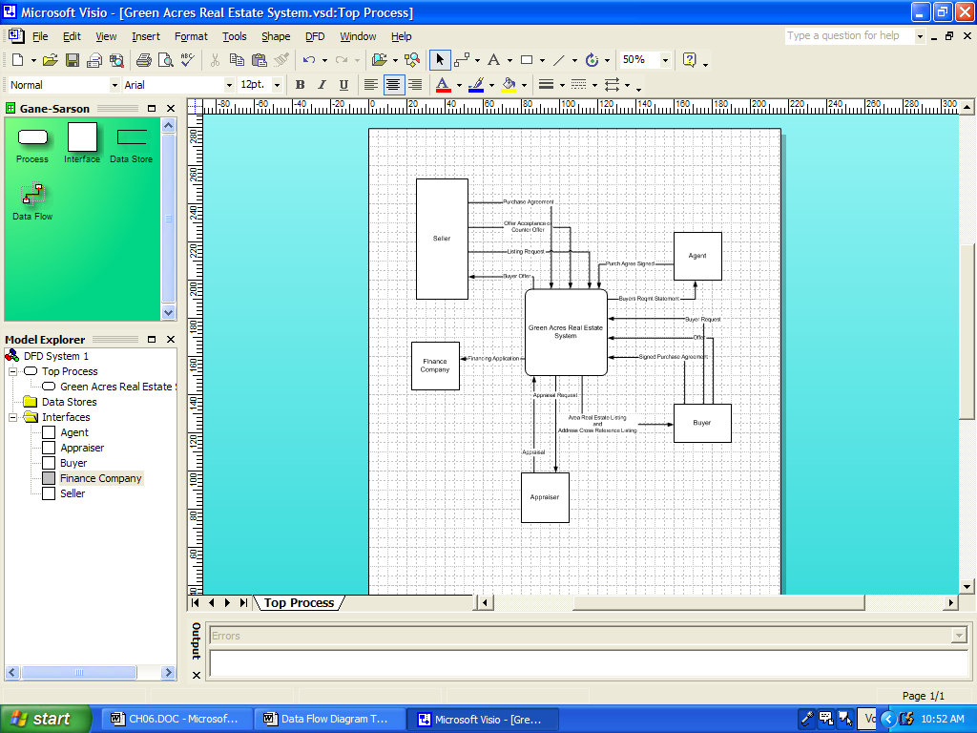
To create the Level 1 DFD you must select the process and click on DFD then New Detail Page.

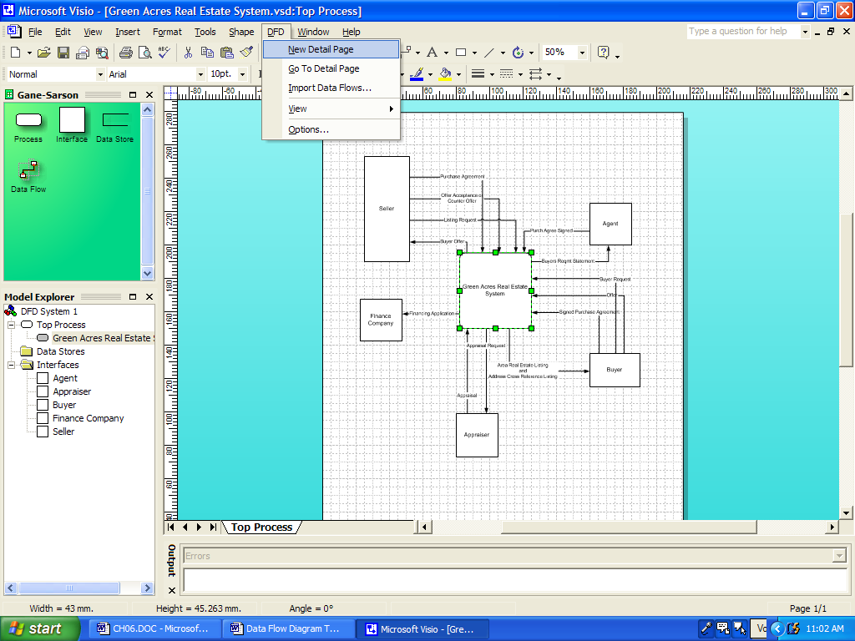

This new page automatically brings forward the data flows and their connected interfaces. This helps keep track as you focus now on the internal processes of the system.

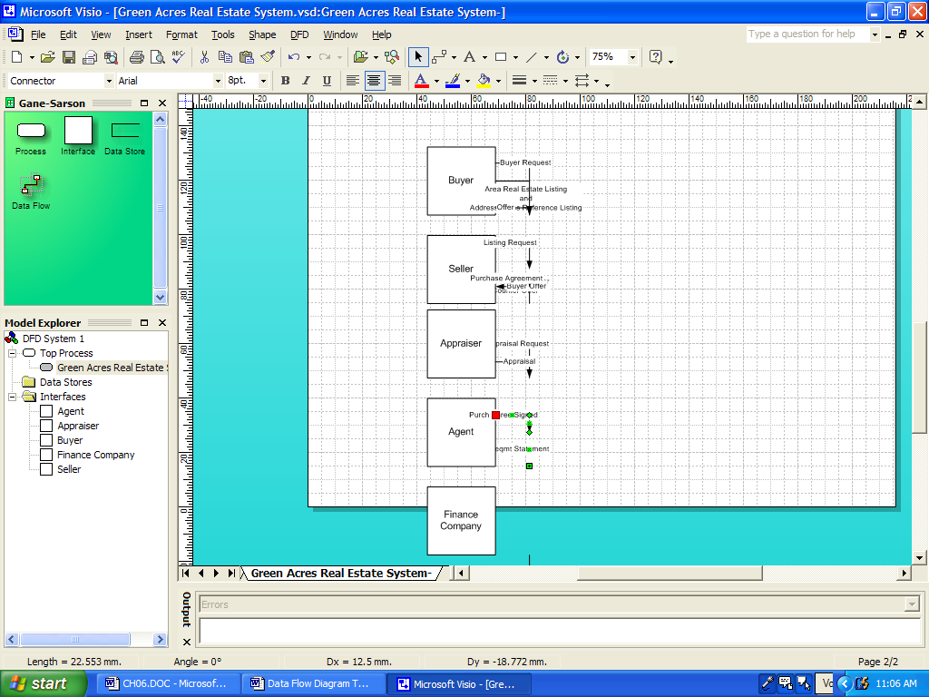

If you have time continue and create the Level 1 DFD for the internal functioning of the Green Acres Real Estate System.

